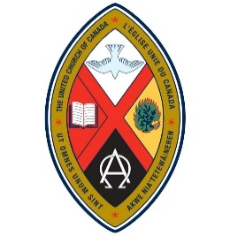

WOMEN OF THE UNITED CHURCH:
CHINOOK WINDS AND NORTHERN SPIRIT
CONFERENCE AND AGM
“Justice and Hope”
April 9, 4:00 p.m. to April 11, 1:00 p.m., 2026
{Registration starting at 2:30 p.m.}
Providence Renewal Centre
3005 – 119 St., Edmonton
All Women of the Church are Welcome
For those booking rooms, please complete the Registration Form and mail with payment to the Registrar by March 14, 2026. Commuters please register by March 27, 2026. Make cheques payable to Women of the United Church (WUC) with Gathering/AGM in the Memo line.

Registrar: Margery Wright, 38 Danforth Cres., St. Albert, AB T8N 4W8
Email: margery.j.wright@gmail.com Phone : 780 419 3224

Financial Assistance is available. See the reverse side for the Christensen/Dryburgh Fund application form.

REGISTRATION FORM
Staying at Providence, single room, bathroom down the hall, all meals and program, $270.
Staying at Providence, room with ensuite bathroom, double, all meals and program, $250 each
Roommate’s name___________________________________________________________________
Commuter Package – not staying at Providence, all meals except breakfast, program, $160

Rates are subsidized, WUC is covering approximately 25% of the cost (you are paying about 75% of cost.)

Name ____________________________________________________________________________________
Address __________________________________________________________________________________
Telephone ____________________________________ Email ______________________________________
Allergies/Dietary Concerns ___________________________________________________________________
Other requests _____________________________________________________________________________
_________________________________________________________________________________________
Role or former role in UCW or WUC (if any)_____________________________________________________

