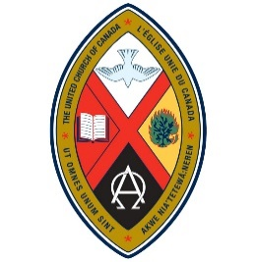
WOMEN OF THE UNITED CHURCH:
CHINOOK WINDS AND NORTHERN SPIRIT
CONFERENCE AND AGM
“For the Beauty of the Earth: Caring for Creation”
May 9, 4:00 p.m. to May 11, 1:00 p.m., 2024
{Registration starting at 2:30 p.m.}
Providence Renewal Centre
3005 – 119 St., Edmonton
All Women of the Church are Welcome
Please complete the Registration Form and mail with payment to the Registrar by April 5, 2024. Commuters please register by April 30, 2024. Make cheques payable to Women of the United Church (WUC) with Gathering/AGM in the Memo line.

Registrar: Margery Wright, 38 Danforth Cres., St. Albert, AB T8N 4W8
Email: margery.j.wright@gmail.com Phone : 780 419 3224

Financial Assistance is available. See the reverse side for information on the Christensen/Dryburgh Fund

REGISTRATION FORM
Staying at Providence, single room, shared bathroom, all meals and program $250.
Staying at Providence, room with ensuite bathroom, single, all meals and program, $290
Staying at Providence, room with ensuite bathroom, double, all meals and program, $155 each
Roommate’s name___________________________________________________________________
Commuter Package – not staying at Providence, includes all meals except breakfast $130

Name ____________________________________________________________________________________
Address __________________________________________________________________________________
Telephone ____________________________________ Email ______________________________________
Allergies/Dietary Concerns ___________________________________________________________________
Other requests _____________________________________________________________________________
_________________________________________________________________________________________

Role or former role in UCW or WUC (if any)_____________________________________________________

