Our resource people: biographies and presentations, Western Intercultural Ministries Network AGM and conference, October 19-21 2023, St Albert AB, Treaty Six.
Click here for the main conference page

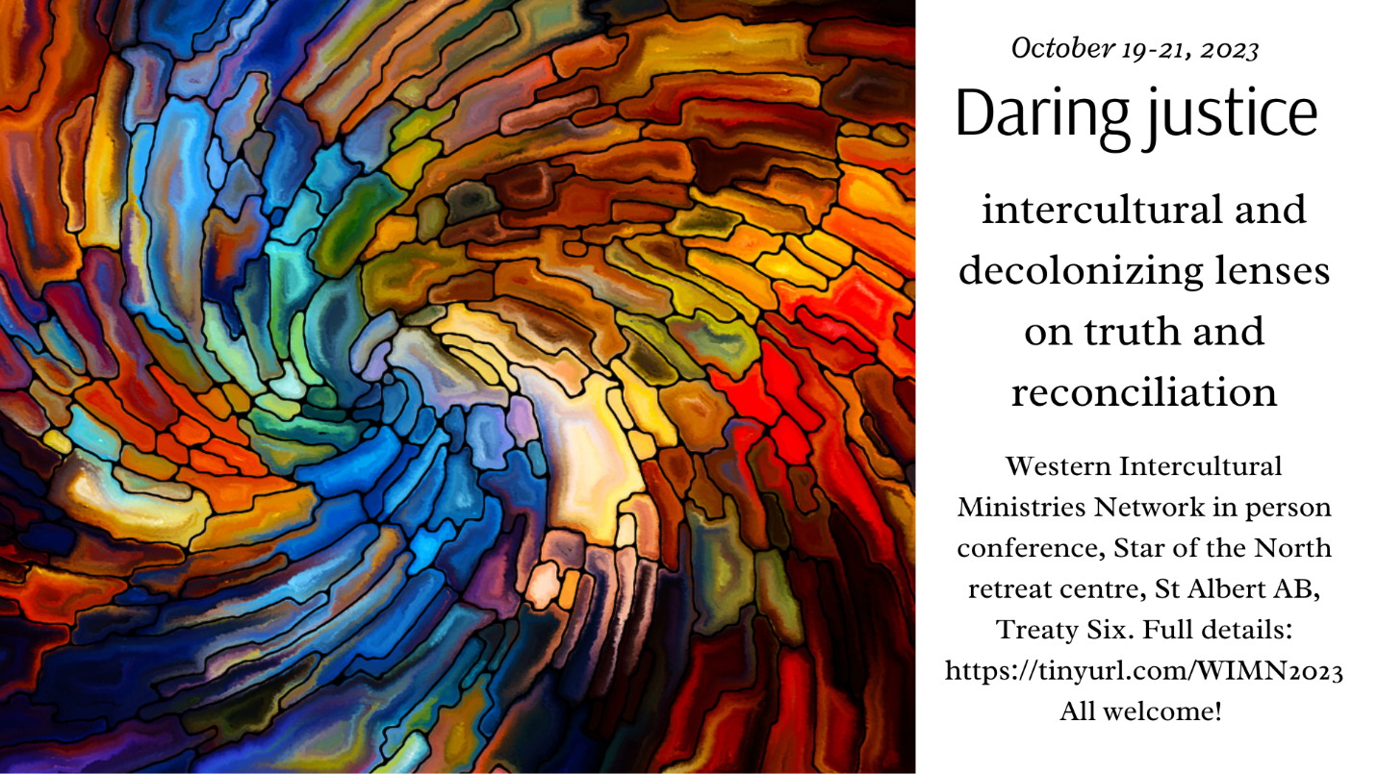

Rev. MiYeon Kim is the minister at Fort Macleod-Granum pastoral charge. Originally from the Presbyterian Church in the Republic of Korea (PROK), MiYeon was admitted to the ministry of the United Church in 2018. She has previously served in two pastoral charges in Northern Spirit Regional Council: Edgerton-Paradise Valley, and Spirit River (where she did her internship). Currently, MiYeon serves on the Admissions Board for the national church, which interviews ministry personnel from other denominations seeking admittance into The United Church of Canada. She is also passionate about music in the church, leading the United We Dance children's music project, and recently she has begun writing her own hymns.

Rev. Lloyd Nyarota was born and raised in Zimbabwe. He has been in the ministry since August 1989 and served in the Zimbabwe United Methodist Church till he came to Canada and started ministry in the United Church of Canada from September 2015.
Lloyd is married to Tazvionep,i a United Methodist Church ordained clergy serving as a missionary in Canada. Lloyd and Tazvionepi are blessed with two children, a son, Lloyd Tinotenda Nyasha, and daughter, Lorraine Tinovimba Chiratidzo.
Lloyd is a holder of diplomas in theology and religious studies, a Bachelor of Divinity and a Masters in Peace, Leadership and Governance. He is currently completing a Ph.D. in Theology with MF, Norwegian School of Theology, Religion and Society. His thesis research is on: The Mission of Reconciliation: The Church’s Message in Zimbabwe 2000-2009.
Rev. Murray Pruden Saddle Lake Cree Nation, Executive Minister, Indigenous Ministries and Justice, General Council.
Chris Pullenayegem is an immigrant from Sri Lanka specialized in law (specializing in refugee and Immigration law and policy), psychology, leading change and innovation and in adult education. Chris grew up in a multi-religious and multi-ethic context among communities fractured along these lines. In Canada he worked as a Refugee Policy Analyst which adds to the wealth of knowledge and experience he brings to the area of migration and Diaspora.
His current work as Director of Congregational Vitality at the Vancouver School of Theology includes building a vision for a new and emerging church in Canada co-created by established and migrant communities of faith, which involves researching and developing resources to facilitate this evolution. His interest in inter-faith work motivated him to lead an Ontario inter-faith coalition on social reform for a while. He is a trainer in cross-cultural competencies and multi-faith awareness and is a keen observer of people movements. Chris has decades of experience working with the Church in matters relating to church renewal, leadership and new ministry development and discipleship/faith formation. He has lots of experience in leading startups/new initiatives and brings passion, people skills and sound strategy to help them grow. Chris finds recreation in music and outdoor activities.
Becca Whitla is the professor of practical ministry and the Dr. Lydia E. Gruchy Chair in Pastoral Theology at St. Andrew’s College in Saskatoon, Saskatchewan where she teaches worship and liturgy, preaching, religious education, and practical theology. Her book Liberation, (De)Coloniality, and Liturgical Practices: Flipping the Song Bird was released in December, 2020 (Palgrave McMillan). From her White Euro-Canadian settler perspective, she examines ways to decolonize liturgical practices, especially community singing. She worked in Toronto for many years as a music director in both Anglican and United Churches (Church of the Holy Trinity, and Trinity St Paul’s United Church). She also co-directed Echo, a 70 voice women’s choir, and worked in the trade union movement developing leadership through choral singing.

